Abdul Wahab
!8P-0171
sec-6B

Q 1:

CREATE USER 'wahab'@'localhost' IDENTIFIED BY '1234';

Q 2.1:

grant select on Themepark.EMPLOYEE to 'wahab'@'localhost';

Q 2.2:

grant select on Themepark.temporary to 'wahab'@'localhost';

Q 2.3:

GRANT ALL PRIVILEGES ON * . * TO 'wahab'@'localhost';

Q 2.4:

grant Create ON * . * TO 'wahab'@'localhost';

Q 3:

revoke select on Themepark.temporary from 'wahab'@'localhost';

Q 4:

grant insert on Themepark.TICKET to 'wahab'@'localhost';

grant insert oN Themepark.TICKET to 'wahab'@'localhost' WITH GRANT OPTION;

Q 5.1:

USE Themepark;

SELECT * FROM TICKET;

COMMIT;
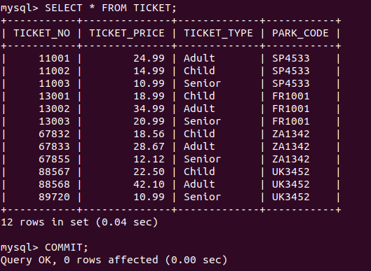

Q 5.2:

